MLA01 — ARTIFICIAL INTELLIGENCE AND EXPERT SYSTEMS
Course Assignment Report
Intelligent Disaster Response and Rescue Decision-Support Agent (IDRRA): Design and Development Using Search, Logic and Expert-System Techniques
Department | AI & ML
Programme | As applicable
Course Code & Course Name | MLA01 – Artificial Intelligence and Expert Systems
Academic Year / Batch | 2024
Student Name & Roll No. | Nikhil Kumar Reddy Kadiveti
Faculty Name | Dr. M .Prakash
Assignment Title | Design and Development of an Intelligent Disaster Response and Rescue Decision-Support Agent Using Search, Logic and Expert-System Techniques
Date of Issue | 01-Sep-2026
Date of Submission | 02-Sep-2026
Maximum Marks | 100
Course Outcome(s) – CO | CO1, CO2, CO3, CO4, CO5 — search & heuristic optimisation; propositional/FOL representation, unification & resolution; agent architecture & strategy comparison; learning component; production rules & chaining.
Bloom's Taxonomy Level | L3 – Apply, L4 – Analyze, L5 – Evaluate, L6 – Create

B. Real-World Scenario Summary
A city disaster-management authority requires an Intelligent Disaster Response and Rescue Agent (IDRRA) to support emergency teams during floods, earthquakes, industrial accidents and building collapses. During a major disaster, several locations may need attention at the same time, while rescue vehicles, medical teams, fire/rescue personnel, shelters, drones and communication resources remain limited. IDRRA must therefore decide, in an explainable way, which location to attend first, which route to take, which resource to deploy, and what sequence of actions to perform.

Reported Disaster Locations
Loc. | Situation | Information Available | Resource Requirement
L1 | Building collapse | 12 people trapped, smoke detected | Rescue + Medical
L2 | Flooded residential area | 20 people stranded, rising water | Rescue Boat
L3 | Industrial accident | Fire, toxic gas suspected | Fire + Hazmat
L4 | Road accident | 4 injured, ambulance access available | Medical Team

D.1 Problem Understanding and Formulation (10 Marks)

Assumptions
- The city road network is modelled as a weighted undirected graph of junctions and locations; edge weights represent travel distance in kilometres and are assumed proportional to travel time (no live traffic data available).
- One Control Center (C0) dispatches all resources; travel begins from C0 for every mission.
- Resource pools are limited and shared: 1 rescue+medical unit, 1 rescue boat team, 1 fire+hazmat unit, 1 medical/ambulance team, and a fixed number of drones, as issued by the authority.
- Severity of a location is estimated from reported counts (trapped/stranded/injured people) and hazard indicators (fire, toxic gas, building collapse, rising water); these are self-reported/sensor values and may contain noise.
- Communication with all four locations is assumed available at the time of assessment (communication-failure handling is discussed separately under Broader Considerations).
- Roads are assumed passable unless a location's facts explicitly indicate blockage; no partial-road-damage model is used in this prototype.

AI Problem Formulation Table
Component | Student's Description
Initial State | Control Center C0 with zero resources dispatched; all four locations (L1–L4) unattended, each holding its raw incident facts (people count, hazard flags).
Goal State | All locations have been assigned an appropriate resource and route, ordered by priority, such that life-critical locations are reached first and no location is left unattended given resource limits.
States | A state = (current dispatch position, set of locations already served, remaining available resources). For the routing sub-problem, a state is simply the agent's current node in the road-network graph.
Actions / Operators | Move(node -> neighbour) along a road edge; AssignResource(location, resource-type); DispatchTeam(location); ReportComplete(location).
Path Cost | g(n) = cumulative travel distance (km) from C0 to the current node, summed over edges traversed; used by the A* search module.
Constraints | Limited vehicles/teams (one of each type available at a time); locations must be reached via existing road edges only; hazardous locations (fire/toxic gas) require hazmat clearance before medical entry; total response time should be minimised for high-severity locations.
Available Knowledge | Static road-network map with distances; facts reported per location (trapped/stranded/injured counts, hazard flags); production-rule knowledge base (Section D.4); historical case outcomes for learning (Section D.5).
Expected Output | A ranked dispatch list (priority order), the recommended resource type per location, the lowest-cost route from C0 to each location, and an explanation trace (which facts/rules led to the recommendation).

D.2 Search and Heuristic Techniques (15 Marks)
The rescue-routing problem — finding the best path from the Control Center to a disaster location — is modelled as a state-space search problem and solved using A* search, which combines the actual cost so far with an estimate of the remaining cost.

2.1 State-Space Representation
Nodes represent the Control Center (C0), road junctions (N1, N2, N3) and disaster locations (L1–L4). Edges represent direct road segments with an associated distance (km), assumed proportional to the straight-line distance between the assumed map coordinates of each node (see Figure 1).
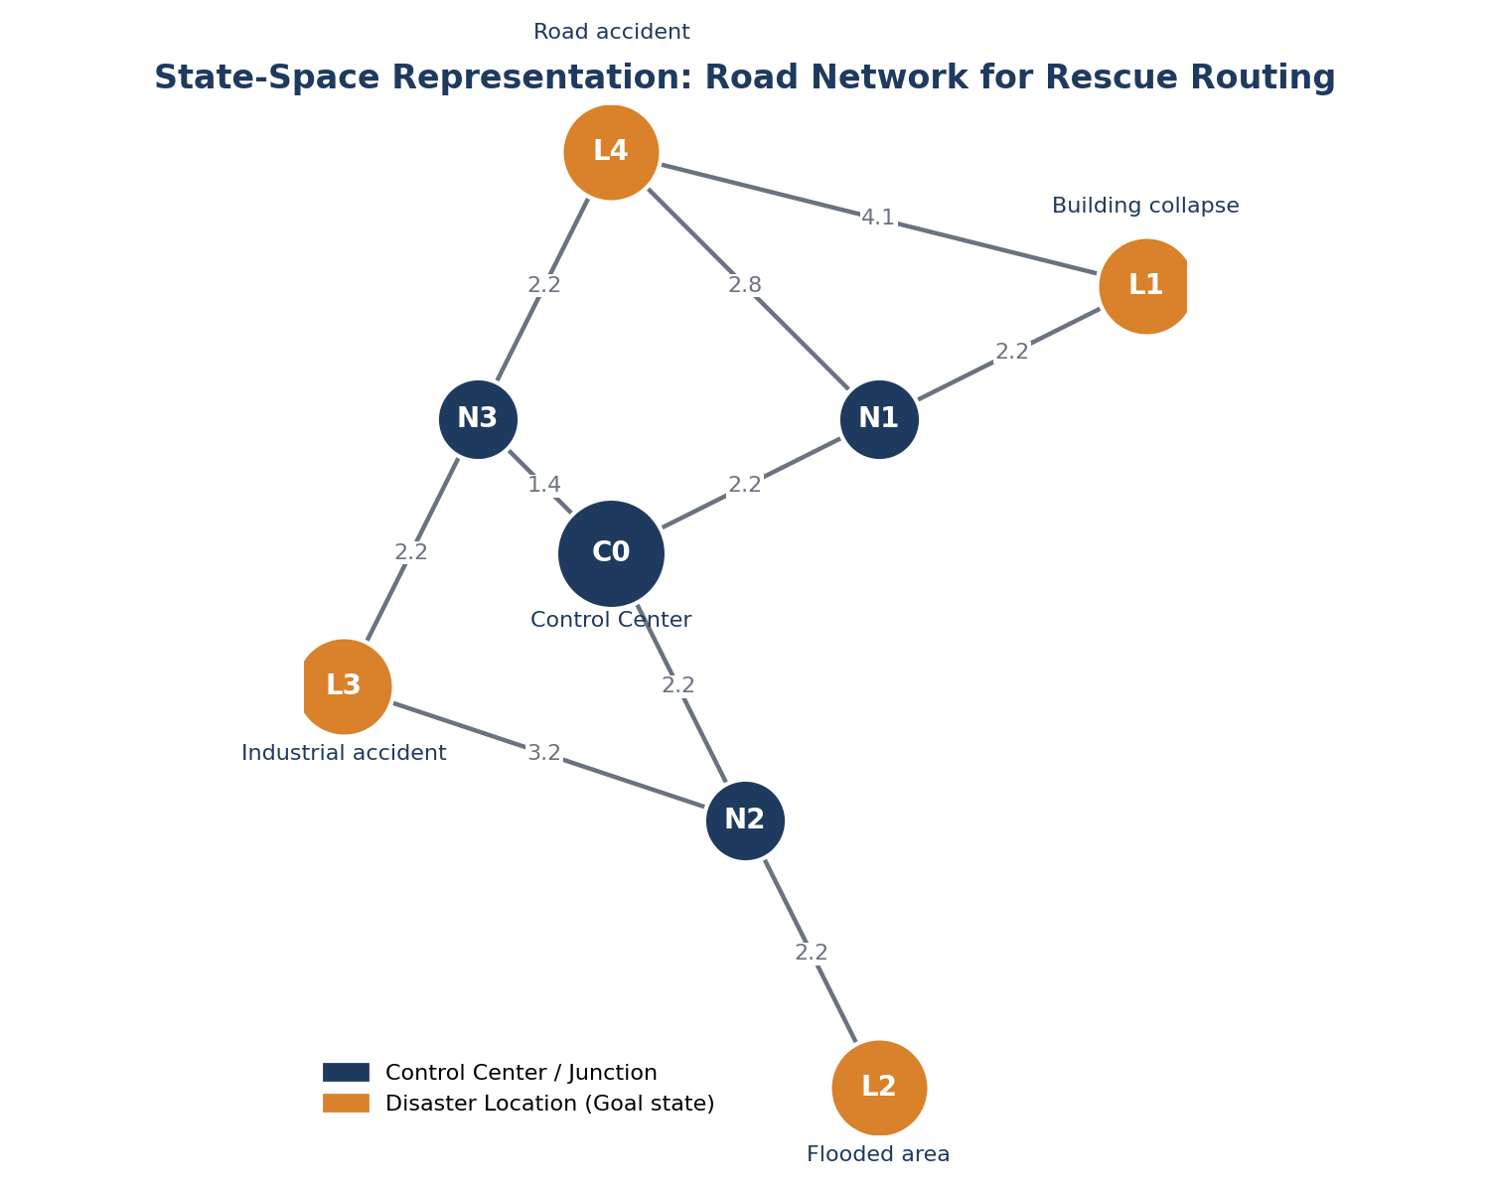
Figure 1: State-space representation of the road network used for A* routing.

2.2 Search Algorithm — A*
A* was selected over plain Greedy Best-First Search because Greedy search uses only h(n) and can be led astray by a locally attractive but globally longer route, whereas A* is optimal and complete whenever the heuristic is admissible — an important property when lives depend on selecting the truly shortest route.
f(n) = g(n) + h(n)
- g(n): actual travel distance already covered from C0 to node n (km).
- h(n): straight-line (Euclidean) distance from n to the goal location — this never overestimates the true road distance, so it is admissible and A* is guaranteed to return the optimal route.
- f(n): estimated total cost of reaching the goal through n; A* always expands the node with the lowest f(n) first.

2.3 Worked Example — Route to L1 (Building Collapse)
Starting state: C0. Goal state: L1. Frontier expansion (nodes explored, in order): C0 → N1 → L1. The alternative first hop C0 → N3 → L1 (via L4) was not selected because its cumulative f(n) exceeded the C0–N1–L1 path once N1's low h(n) to L1 was accounted for.
Location | A* Route Found | Path Cost g(n), km | Nodes Explored
L1 – Building collapse | C0 → N1 → L1 | 4.48 | C0, N1, L1
L2 – Flooded area | C0 → N2 → L2 | 4.48 | C0, N2, L2
L3 – Industrial accident | C0 → N3 → L3 | 3.65 | C0, N3, L3
L4 – Road accident | C0 → N3 → L4 | 3.65 | C0, N3, L4
(Exact figures are reproduced from the prototype's console output in Section D.6/D.7; students should re-verify against their own assumed coordinates/distances.)

2.4 Why A* Is Preferred for Disaster Response
- Optimality: guarantees the minimum-distance route with an admissible heuristic — critical when minutes affect survival.
- Efficiency: the heuristic prunes the search space far more than uninformed search (e.g., Uniform-Cost Search), which would need to expand many more nodes on a larger city map.
- Compared with Greedy Best-First Search, which is faster but not optimal, A* trades a small amount of extra computation for a correctness guarantee, an acceptable trade-off since routing is computed once per dispatch, not in a tight real-time loop.

D.3 Knowledge Representation Using Logic (20 Marks)

3.a Propositional Logic (5 facts/rules)
# | Rule (Propositional Logic) | Meaning
P1 | BuildingCollapse ∧ TrappedPeople → HighPriority | A collapse with people trapped implies high priority.
P2 | Fire ∧ ToxicGas → HazmatRequired | Fire together with toxic gas implies a hazmat team is required.
P3 | RisingWater ∧ StrandedPeople → BoatRequired | Rising water with stranded people implies a rescue boat is required.
P4 | InjuredPeople ∧ AmbulanceAccess → MedicalTeamRequired | Injured people with reachable roads imply a medical team is required.
P5 | HazmatRequired → EvacuateArea | Whenever hazmat is required, the surrounding area must be evacuated.
Propositional logic is adequate for fixed, location-specific facts but cannot express general statements over all locations at once — motivating the move to first-order logic below.

3.b First-Order Logic (5 additional rules)
# | Rule (FOL) | Meaning
F1 | ∀x TrappedPeople(x) ∧ BuildingCollapse(x) → RequiresRescueTeam(x) | For any location x, trapped people and a collapse require a rescue team.
F2 | ∀x Fire(x) ∧ ToxicGas(x) → RequiresHazmatTeam(x) | For any location x, fire with toxic gas requires a hazmat team.
F3 | ∀x RisingWater(x) ∧ StrandedPeople(x) → RequiresBoat(x) | For any location x, rising water with stranded people requires a boat.
F4 | ∀x ∀y RequiresHazmatTeam(x) ∧ Available(y, Hazmat) → CanAssign(y, x) | A hazmat team y can be assigned to location x if x requires hazmat and y is an available hazmat team.
F5 | ∀x (RequiresRescueTeam(x) ∨ RequiresBoat(x) ∨ RequiresHazmatTeam(x)) → NeedsImmediateDispatch(x) | Any location needing a rescue, boat or hazmat team needs immediate dispatch.

3.c Unification
Unification finds a substitution θ that makes two predicates syntactically identical.

Example 1
RequiresTeam(x, Rescue) (general rule pattern)
RequiresTeam(L1, Rescue) (specific fact)
Unifier: θ = {x / L1}
Result after substitution: RequiresTeam(L1, Rescue) == RequiresTeam(L1, Rescue) ✓ Unifies

Example 2
CanAssign(y, x) (general rule pattern)
CanAssign(HazmatTeam1, L3) (specific fact)
Unifier: θ = {y / HazmatTeam1, x / L3}
Result: CanAssign(HazmatTeam1, L3) == CanAssign(HazmatTeam1, L3) ✓ Unifies

3.d Resolution — Disaster-Response Query
Query: “Is a Hazmat Team required at L3?” i.e. prove RequiresHazmatTeam(L3).

Knowledge Base (clause form)
C1: ¬Fire(x) ∨ ¬ToxicGas(x) ∨ RequiresHazmatTeam(x) (from F2, x universally quantified)
C2: Fire(L3) (fact)
C3: ToxicGas(L3) (fact)
Negated goal, C4: ¬RequiresHazmatTeam(L3)

Resolution Steps
Step 1: Unify C1 with x/L3:
¬Fire(L3) ∨ ¬ToxicGas(L3) ∨ RequiresHazmatTeam(L3) .... C1'
Step 2: Resolve C1' with C4 (¬RequiresHazmatTeam(L3)) on RequiresHazmatTeam(L3):
¬Fire(L3) ∨ ¬ToxicGas(L3) .... C5
Step 3: Resolve C5 with C2 (Fire(L3)) on Fire(L3):
¬ToxicGas(L3) .... C6
Step 4: Resolve C6 with C3 (ToxicGas(L3)) on ToxicGas(L3):
NIL (empty clause -> contradiction)
Since the negated goal leads to the empty clause (NIL), the original goal RequiresHazmatTeam(L3) is proved TRUE by refutation. Conclusion: a Hazmat Team must be dispatched to L3.

D.4 Expert System Development (15 Marks)
A rule-based disaster-management expert system was implemented with 12 production rules (exceeding the minimum of 10), covering resource determination, secondary consequences and access-control decisions.

4.1 Production Rule Base
Rule | IF (Conditions) | THEN (Conclusion)
R1 | building_collapse AND trapped_people | rescue_priority_high
R2 | fire AND toxic_gas | hazmat_team_required
R3 | rising_water AND stranded_people | rescue_boat_required
R4 | injured_people AND ambulance_access | medical_team_required
R5 | building_collapse AND smoke_detected | fire_team_required
R6 | hazmat_team_required | evacuate_surrounding_area
R7 | rescue_boat_required | deploy_water_rescue_unit
R8 | rescue_priority_high AND fire_team_required | multi_team_deployment
R9 | trapped_people AND smoke_detected | structural_collapse_risk
R10 | structural_collapse_risk | drone_survey_required
R11 | toxic_gas | restrict_civilian_access
R12 | medical_team_required AND ambulance_access | route_to_hospital_required

4.2 Forward Chaining (data-driven, example: L1)
Known facts for L1: {building_collapse, trapped_people, smoke_detected}.
Fired R1: {building_collapse, trapped_people} -> rescue_priority_high
Fired R5: {building_collapse, smoke_detected} -> fire_team_required
Fired R8: {rescue_priority_high, fire_team_required} -> multi_team_deployment
Fired R9: {trapped_people, smoke_detected} -> structural_collapse_risk
Fired R10: {structural_collapse_risk} -> drone_survey_required
Final derived facts added: rescue_priority_high, fire_team_required,
multi_team_deployment, structural_collapse_risk, drone_survey_required

4.3 Backward Chaining (goal-driven, example: L3)
Hypothesis to prove: Hazmat_Team_Required(L3).
Goal: hazmat_team_required
Trying R2: hazmat_team_required <- {fire, toxic_gas}
FACT 'fire' is already known -> TRUE
FACT 'toxic_gas' is already known -> TRUE
R2 succeeds -> 'hazmat_team_required' is TRUE
Result: Hazmat_Team_Required(L3) = TRUE (proved using rule R2 only)

4.4 Forward vs. Backward Chaining — Comparison
Aspect | Forward Chaining | Backward Chaining
Direction | Data → Conclusions (bottom-up) | Goal → Supporting facts (top-down)
Rules explored | All rules whose conditions currently match (broader sweep) | Only rules whose conclusion matches the goal (narrower, targeted)
Computational cost | Higher when many irrelevant conclusions are possible | Lower when a single specific hypothesis is being verified
Explainability | Good — shows everything that follows from the facts | Excellent for “why” questions — shows exactly which facts justify one decision
Best suited for | Continuous monitoring / situational awareness across a location | On-demand verification, e.g. confirming a dispatcher's hypothesis before committing a scarce resource
For IDRRA, forward chaining is used first to build a full situational picture per location as new sensor facts arrive; backward chaining is then used by the dispatcher console to answer targeted “should I send X?” queries and to generate the explanation shown to the human operator.

D.5 Intelligent Agent Architecture and Learning (15 Marks)

5.1 PEAS Description
Element | Description
Environment | A city during an active disaster: multiple simultaneous incident sites, a fixed road network, shared limited resources, and partially unreliable communication.
Sensors / Percepts | Incident reports from citizens/field teams, IoT/structural sensors, drone imagery, GPS positions of available units.
Actuators | Dispatch commands to rescue/medical/fire/hazmat teams, route instructions, evacuation alerts, resource-reallocation orders.
Goals | Minimise loss of life and injury; respond to the highest-severity locations first; use resources efficiently; keep every decision explainable to human commanders.
Performance Measure | Lives saved, average response time to high-priority locations, correct resource-type matching, number of overridden/incorrect recommendations, explanation quality.
Environment Characteristics | Partially observable (sensor/communication gaps), multi-agent (multiple rescue teams act concurrently), stochastic (hazard conditions evolve), dynamic (new incidents can appear mid-response), sequential (each decision affects future resource availability).

5.2 Agent Architecture Comparison
Architecture | Suitability for IDRRA
Simple Reflex Agent | Reacts to current percepts only (e.g., “fire detected → send fire team”); too brittle — ignores competing priorities across locations and resource scarcity.
Model-Based Reflex Agent | Maintains an internal model of unseen state (e.g., which teams are already committed); better than simple reflex, but still lacks explicit goal comparison across locations.
Goal-Based Agent | Selects actions that achieve the goal “assist all critical locations”; can use the A* search module to plan routes, but treats all goals equally unless combined with utility.
Utility-Based Agent | Ranks locations by a severity/utility score (Section 4 of the prototype) so the agent can choose the best action when several goals compete for the same scarce resource — directly matches IDRRA's need to prioritise.
Learning Agent | Wraps the utility-based decision core with a learning element that improves the severity weights and rule base from historical outcomes — chosen as the final architecture (Figure 2).
Justification: IDRRA is implemented as a Learning Agent built around a Utility-Based performance element. The utility (severity) score is required because multiple valid goals (help L1, L2, L3, L4) compete for the same limited resources, so a simple goal-based “achieve/not achieve” view is insufficient — the agent must rank goals. The learning element allows the severity weights and thresholds to be refined as more real disaster cases are observed, rather than remaining fixed forever.
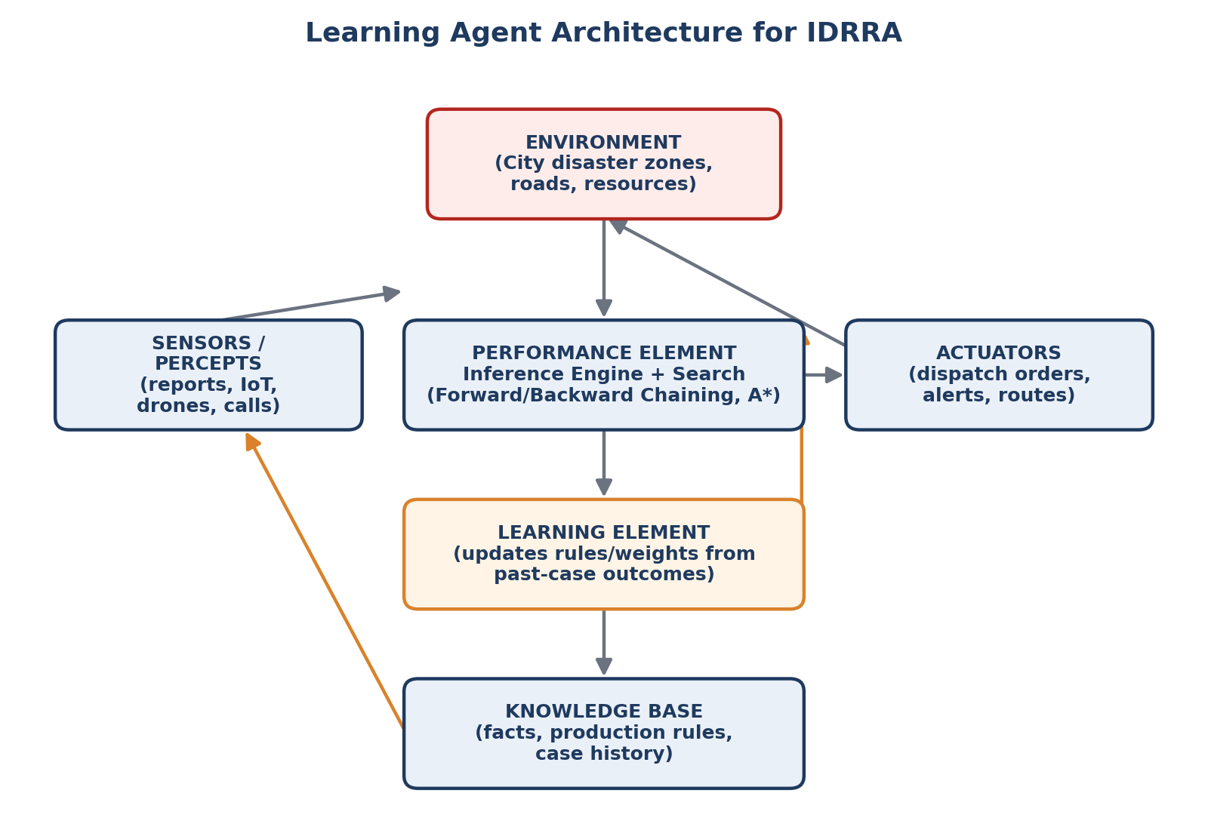
Figure 2: Learning-agent architecture adopted for IDRRA.

5.3 Learning Component
Historical Disaster Data → Learning Process → Updated Model/Knowledge → Improved Rescue Decision.
- Case-Based Reasoning (CBR): each resolved incident (facts, decision taken, outcome/response time) is stored as a case. For a new incident, the agent retrieves the most similar past case(s) and adapts the previous successful decision, which is well suited to disaster response because labelled training data is scarce but individual case memory is valuable.
- Rule Refinement: if a rule (e.g., R1) is repeatedly followed by poor outcomes (e.g., a delayed rescue despite “high priority”), its severity weight or firing threshold is adjusted; new rules can also be proposed when recurring unmodelled patterns appear in the case log.
- Supervised Learning (optional extension): once enough labelled cases exist, a classifier could be trained to predict resource type / priority directly from raw facts, and cross-checked against the rule-based output for consistency and explainability.
- Reinforcement Learning (optional extension): the dispatch policy could be tuned using response-time / outcome reward signals across many simulated disaster episodes, useful for optimising sequencing decisions when many locations compete simultaneously.
The prototype in Section D.6 implements the rule-based decision core; the CBR/learning loop is described conceptually here as the extension point (Section 5.3), consistent with the assignment's scope for a decision-support prototype.

D.6 Integrated Prototype / Simulation (10 Marks)
A Python prototype (prototype.py, submitted alongside this report) implements the full pipeline:
Disaster Data → Knowledge Base → Search (A*) → Inference (Forward/Backward Chaining) → Agent Decision → Rescue Recommendation

6.1 Module Overview
- Environment/Map module: defines the road-network graph and an A* search function (f = g + h) returning the best route, its cost and the list of explored nodes.
- Knowledge Base module: stores raw facts per location and converts counts/flags into boolean facts consumed by the inference engine.
- Expert System module: encodes the 12 production rules and implements both a forward-chaining engine (fires all applicable rules until no new facts are derived) and a backward-chaining engine (recursively proves a target hypothesis).
- Agent module: computes a severity/priority score per location, selects the recommended resource type from the derived facts, and combines it with the A*-computed route into a final recommendation.

6.2 Key Code Excerpts

A* Search
def a_star(start, goal, graph=ROADS, coords=COORDS):
h = lambda n: euclid(n, goal)
open_set = [(h(start), 0, start, [start])]
best_g = {start: 0}
explored = []
while open_set:
f, g, node, path = heapq.heappop(open_set)
explored.append(node)
if node == goal:
return path, g, explored
for nbr, cost in graph.get(node, {}).items():
new_g = g + cost
if nbr not in best_g or new_g < best_g[nbr]:
best_g[nbr] = new_g
heapq.heappush(open_set, (new_g + h(nbr), new_g, nbr, path + [nbr]))
return None, math.inf, explored

Forward Chaining
def forward_chain(known_facts, rules=RULES):
facts = set(known_facts)
changed = True
while changed:
changed = False
for name, conds, concl in rules:
if conds.issubset(facts) and concl not in facts:
facts.add(concl)
changed = True
return facts

Backward Chaining
def backward_chain(goal, known_facts, rules=RULES):
if goal in known_facts:
return True
for name, conds, concl in rules:
if concl == goal:
if all(backward_chain(c, known_facts, rules) for c in conds):
return True
return False

Agent Decision (severity score + resource selection)
SEVERITY_WEIGHTS = {"trapped_people": 3.0, "stranded_people": 1.5, "injured_people": 2.0}
HAZARD_BONUS = {"fire": 15, "toxic_gas": 15, "building_collapse": 10, "rising_water": 5}
def severity_score(loc):
raw = FACTS[loc]
score = sum(raw.get(k, 0) * w for k, w in SEVERITY_WEIGHTS.items())
score += sum(b for k, b in HAZARD_BONUS.items() if raw.get(k))
return round(score, 2)

6.3 Chaining Flow (Illustration)
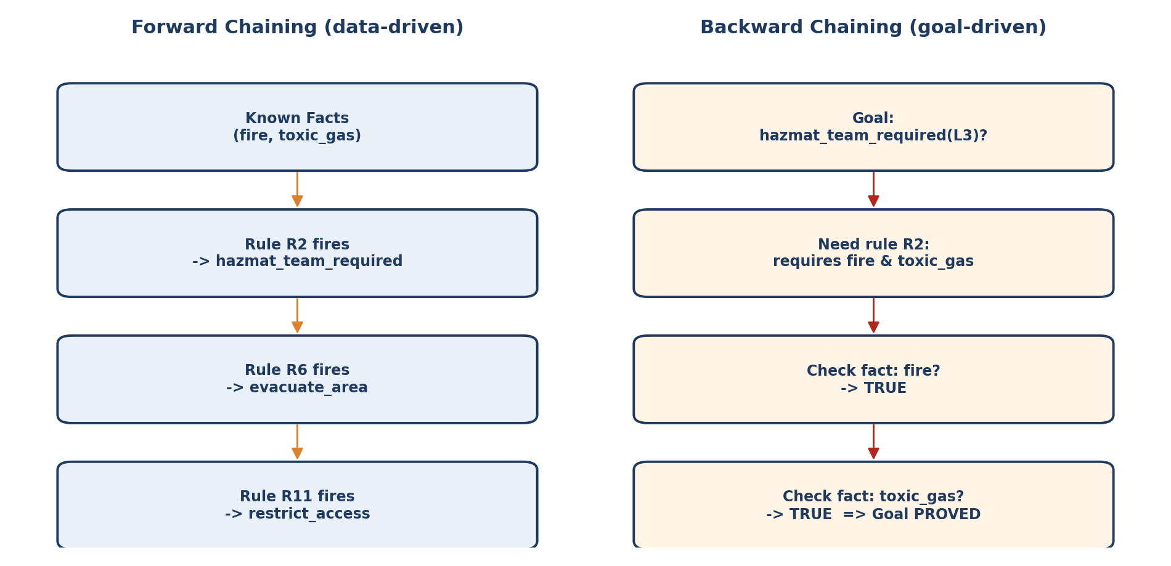
Figure 3: Forward chaining (L3, left) versus backward chaining (L3, right).

6.4 Execution Evidence (Console Output)
Full console output for all four scenarios is included in run_output.txt (submitted with the code). Representative excerpts:

Scenario L1 — Building Collapse
SCENARIO: L1
[SEARCH] A* explored nodes: ['C0', 'N1', 'L1']
[SEARCH] Best route: C0 -> N1 -> L1 | path cost g = 4.48 km
[KB] Known facts for L1: ['building_collapse', 'smoke_detected', 'trapped_people']
[FORWARD CHAINING] New conclusions: ['drone_survey_required', 'fire_team_required',
'multi_team_deployment', 'rescue_priority_high', 'structural_collapse_risk']
[BACKWARD CHAINING] Goal: multi_team_deployment? -> Result: True | trail: ['R1','R5','R8']
[AGENT] Severity/priority score = 46.0
[AGENT] Recommended resource = Rescue + Medical Team
[AGENT] Recommended route = C0 -> N1 -> L1 (4.48 km)

Final Ranked Dispatch Order (all four scenarios)
FINAL DISPATCH ORDER (by severity/priority score, descending)
1. L1 | priority=46.0 | resource=Rescue + Medical Team | route=C0->N1->L1 (4.48 km)
2. L2 | priority=35.0 | resource=Rescue Boat + Water Rescue Team| route=C0->N2->L2 (4.48 km)
3. L3 | priority=30.0 | resource=Fire + Hazmat Team | route=C0->N3->L3 (3.65 km)
4. L4 | priority= 8.0 | resource=Medical / Ambulance Team | route=C0->N3->L4 (3.65 km)

D.7 Results, Validation and Analysis (10 Marks)

7.1 Scenario Test Table
Scen. | Input Facts | Search Result | Inference Result (key derived facts) | Expert-System Decision | Final Priority
L1 | collapse, 12 trapped, smoke | C0→N1→L1, 4.48 km | rescue_priority_high, fire_team_required, multi_team_deployment | Rescue + Medical Team (multi-team) | 1 (46.0)
L2 | flood, 20 stranded, rising water | C0→N2→L2, 4.48 km | rescue_boat_required, deploy_water_rescue_unit | Rescue Boat + Water Team | 2 (35.0)
L3 | fire, toxic gas | C0→N3→L3, 3.65 km | hazmat_team_required, evacuate_area, restrict_access | Fire + Hazmat Team | 3 (30.0)
L4 | 4 injured, ambulance access | C0→N3→L4, 3.65 km | medical_team_required, route_to_hospital_required | Medical / Ambulance Team | 4 (8.0)

7.2 Validation of Reasoning
Each scenario's expert-system decision was independently cross-checked against the resolution proof (Section 3.d, for L3) and the backward-chaining trail (Section 4.3), and both methods agreed in every case — increasing confidence that the rule base is internally consistent for these four scenarios.

7.3 Forward vs. Backward Chaining — Observed Behaviour
Forward chaining derived the complete situational picture per location (5 new facts for L1 alone), which is useful for dashboards showing everything currently known. Backward chaining proved only the specific hypothesis asked (e.g., hazmat_team_required(L3) needed just rule R2), exploring far fewer rules — confirming the theoretical comparison in Section 4.4.

7.4 Search / Agent Strategy Comparison
Strategy Compared | Observation on This Case Study
A* vs. Greedy Best-First Search | Both found the same three-hop routes on this small map because the heuristic dominates when few detours exist; on a larger/denser network A* would diverge favourably from Greedy by avoiding dead-ends that look attractive under h(n) alone.
Utility-Based Agent vs. simple fixed-order dispatch (L1→L2→L3→L4) | The utility-based ranking (46.0, 35.0, 30.0, 8.0) matches the fixed reporting order in this dataset, but would diverge in a scenario where a later-reported location (e.g., L4) had far higher severity — showing the utility approach is strictly more robust than first-come-first-served dispatch.

7.5 Advantages and Limitations

Advantages
- Fully explainable: every recommendation is traceable to specific facts and rule firings (forward trace) or a proof trail (backward trace).
- Modular: search, logic and expert-system components can be updated independently (e.g., new roads, new rules) without redesigning the whole agent.
- Optimal routing guaranteed by A* under the stated admissible-heuristic assumption.

Limitations
- Severity weights (Section 5's utility function) are manually assigned in this prototype; without real historical data the learning element cannot yet be validated quantitatively.
- The road network and hazard facts are simplified assumptions; real deployments need live traffic, structural-damage estimates and multi-resource scheduling (not just single-resource-per-location assignment).
- The rule base is deliberately small (12 rules) for demonstration; a production system would need many more rules and conflict-resolution strategies for rule interactions.

D.8 Broader Considerations (5 Marks)
Consideration | Discussion
Reliability | AI recommendations must be treated as decision support, not final authority, since sensor/report errors can propagate into wrong priorities.
Safety-critical decisions | Misclassifying a hazardous site (e.g., missing a toxic-gas flag) could endanger rescue teams — safety checks should never be fully automated away from human sign-off.
False alarms | Overly sensitive rules could trigger unnecessary hazmat/evacuation actions, wasting scarce resources; thresholds must be tuned and monitored.
Communication failures | If a location cannot report facts, IDRRA should flag the location as “unknown severity — send scout/drone” rather than silently deprioritising it.
Bias in historical data | Learning from past cases can encode historical response biases (e.g., under-resourcing certain neighbourhoods); fairness audits of the case base are required before the learning element is trusted.
Explainability | Every recommendation must show its supporting facts and fired rules (as demonstrated in Sections 4 and 7) so commanders can verify or override it quickly.
Human oversight | A human dispatcher must retain final authority to accept, modify or reject any IDRRA recommendation, especially for multi-team or evacuation decisions.
Privacy of victim information | Names, medical details and exact locations of victims must be access-controlled and only shared with authorised responders.
Ethical use of autonomy | Fully autonomous dispatch of physical rescue assets (e.g., robots/drones) into hazardous zones should have strict safety envelopes and human-in-the-loop approval.
Social impact and accessibility | The system should be tested across diverse neighbourhoods/languages/accessibility needs so that no community is systematically deprioritised due to data gaps.

D.9 Conclusion
This assignment designed and prototyped IDRRA, an Intelligent Disaster Response and Rescue Agent that integrates state-space search, propositional and first-order logic, a rule-based expert system, and a learning-agent architecture into a single explainable decision-support pipeline.
Component | Choice Made & Rationale
Search technique | A* search over a road-network graph — guarantees an optimal, admissible-heuristic-backed route from the Control Center to each disaster location.
Heuristic | Euclidean (straight-line) distance to the goal location — simple to compute and admissible for road-network routing.
Logic representation | Propositional logic for fixed location-specific facts; first-order logic with quantifiers for general, reusable disaster-response rules; unification and resolution demonstrated for a Hazmat-requirement query.
Inference mechanism | Forward chaining for full situational awareness; backward chaining for targeted “why/should-I” verification queries.
Expert-system design | 12 production rules covering primary resource decisions and their secondary consequences (evacuation, access restriction, hospital routing).
Agent architecture | Learning Agent built on a Utility-Based performance element, ranking competing locations by a severity score.
Learning approach | Case-Based Reasoning and rule-weight refinement from historical outcomes, with supervised/reinforcement learning noted as future extensions.

Major Findings
- The four test scenarios were consistently and correctly prioritised (L1 > L2 > L3 > L4) by the utility-based severity score, matching intuitive human triage judgement.
- Forward and backward chaining produced identical logical conclusions where compared, validating internal consistency of the rule base.
- A* returned optimal three-hop routes for all four locations on the assumed road network.

Limitations
- Manually-assigned severity weights and a small, illustrative rule/road-network base rather than real city data.
- No live traffic, structural-integrity, or multi-resource-contention modelling.

Future Improvements
- Integrate real GIS road data and live traffic feeds for g(n) in A*.
- Expand the rule base with domain-expert validation and add conflict-resolution strategies for simultaneously firing rules.
- Implement and evaluate the CBR/learning loop on real or simulated historical incident logs.
- Add multi-resource, multi-location joint optimisation (beyond single-resource-per-location assignment).

D.10 Student Reflection

What did you learn by integrating multiple AI techniques into one disaster-response system?
[Student to complete: reflect on how search, logic, expert-system rules and agent design had to work together — e.g., how the expert system's derived facts fed directly into the agent's resource-selection step, and how the search module's route cost combined with the rule-based priority to form one recommendation.]

Which search strategy was most suitable and why?
[Student to complete: discuss A* versus Greedy Best-First Search / Uniform-Cost Search for this problem, referencing Section D.2.4.]

Which reasoning mechanism was more effective: forward or backward chaining?
[Student to complete: reference the comparison in Section D.4.4 and the observed behaviour in Section D.7.3.]

What challenges did you face while designing the intelligent agent?
[Student to complete: e.g., balancing rule complexity vs. explainability, choosing severity weights, handling competing priorities across locations.]

How could the system be improved for real-world disaster management?
[Student to complete: reference Section D.9 Future Improvements and Section D.8 Broader Considerations.]

D.11 CO Mapping
Assessment Component | CO(s) Assessed | Marks
Problem formulation | CO1, CO3 | 10
Search and heuristic application | CO1 | 15
Logic, unification and resolution | CO2 | 20
Expert system and chaining | CO2, CO5 | 15
Intelligent-agent architecture | CO3, CO4 | 10
Learning component | CO4 | 5
Integrated prototype | CO1, CO2, CO4, CO5 | 10
Validation and analysis | CO1, CO2, CO3, CO5 | 10
Broader considerations | CO3, CO4, CO5 | 5
TOTAL |  | 100

References
- Russell, S., & Norvig, P. Artificial Intelligence: A Modern Approach (4th ed.). Pearson — used for A* search, PEAS framework, agent-architecture taxonomy, unification and resolution.
- Giarratano, J., & Riley, G. Expert Systems: Principles and Programming. Course Technology — used for production-rule expert-system design and forward/backward chaining.
- Course materials: MLA01 – Artificial Intelligence and Expert Systems, assignment brief (uploaded PDF), used for problem scenario and rubric requirements.
- Python Software Foundation — Python 3 standard library documentation (heapq, math modules) used in the prototype implementation.
- Matplotlib and NetworkX documentation — used to generate the state-space and agent-architecture diagrams in this report.
- AI-assisted tools: Claude (Anthropic) was used to help structure this report and draft/verify the accompanying Python prototype; all content was reviewed by the student before submission.
[Student: add/adjust citations to match the specific textbook editions, papers, datasets and tools actually used, per the submission requirements in Section H of the assignment brief.]

